Test matrix for Lab 7, SDEV 300 6381, John Leckie

The following table and pictures outline testing scenarios for Lab 7. Pylint results are first, followed by a table of the testing matrix, and then screens of the multiple runs used to obtain the results that went into the matrix. In the screenshots that appear below the matrix, there will be titles indicating to which test case(s) they are applicable.

PYLINT SCREENS

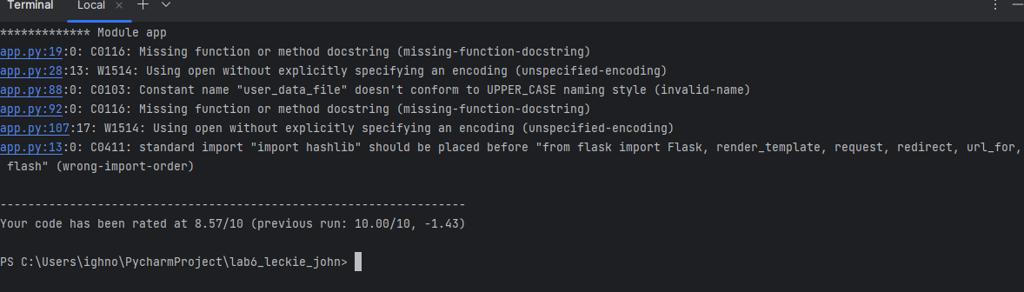

This reminded me (happens every time) to put some docstrings on a couple of functions I missed. There’s a ‘best practice' order to import declarations which I get to learn a little bit about with each project. The file usage (read, append) isn’t enough in best practice. I had to do a little research and find out that ‘utf-8’ is the format found in .txt files, unless I misunderstand.

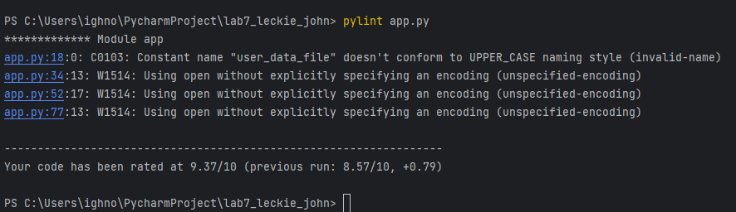

Once I fixed these a bit at a time, and then changed my constant name (I didn’t regard it as a ‘constant’ since it changes... what’s up with that?), I finally got my 10.0.

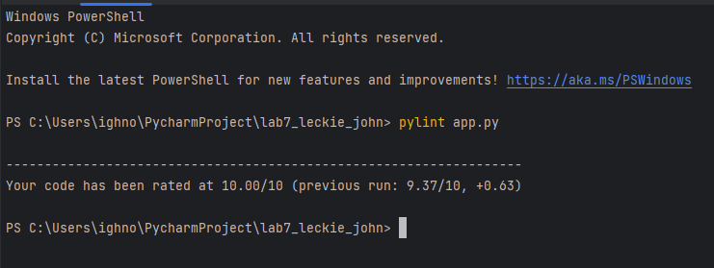

NOTE REGARDING LAYOUT—Aspect ratio and resolution, while they do not affect the desired functions of the website, did give me problems when trying to program this for nearly any layout. (Right half of screen, left half, big window, small window...) Therefore, I request that it be viewed in full screen, which is 16:9 or 16:10 in some cases.

This ‘story’ is hard to tell in pictures. I wish we could submit video.

TEST MATRIX

|  |  |  |  |  |
| --- | --- | --- | --- | --- |
| TEST CASE | HOW TESTED | EXPECTED OUTPUT | ACTUAL OUTPUT | PASS (Y/N)? |
| 1.  Incorrect Login | We start with the user_data.txt having one line with my login/pw. Will test jleckie/#pw after entering the pw incorrectly, using ‘nongrata’ | Invalid login message displays using flash, user remains at login screen until username/pw combination matches what is on file. | As expected | Y |
| 2. Registration with existing username | Username ‘jleckie’ already exists. Will attempt registration with username ‘jleckie’ | Message through flash states that the username already exists and prompts the user to return to the login page.  Note that the option to return to the login page exists before this, on the bottom left, in case a mistake was made in requesting the registration page. | As expected | Y |
| 3. Registration is attempted with the password confirmation not matching the originally requested password | New account ‘ighnot’ requested, but passwords are ‘NongrataPersona9@’ and ‘NongrataPersona92’ because user missed a shift key. | Message through flash explains that the passwords do not match and prompts another attempt until registration is successful. | As expected | Y |
| 4. Registration is attempted with the username and/or password containing spaces. | Username ‘rlec kie’ will be used, as well as password ‘Persona Nongrata4$’ to test program’s reaction | Message through flash that spaces were found in username or password. Will be prompted for all the info again, so both possibilities are protected | Did not work! Screenshot shows where the user_data.txt was written to with the rleckie username containing a space.  UPDATE: Code was added to protect against spaces. Fixed. Next follow-up screenshot shows proper values in user_data.txt | N, Y |
| 5.  After successful login, a logout results in being unable to access the site unless a login is accomplished again. | I will login as jleckie / Migglechiggle1@ and click the ‘Logout’ link below the page content. After I’ve done this, I will attempt to manually enter the URLs that the index.html serves as the gateway for. I will post screenshots of the result of that. | After screenshotted “logout successful” message, User should see no content on the three sub-pages (or even the main page) when entered manually at the address bar. | URLs:  127.0.0.1:5000/planetarium.html  127.0.0.1:5000/supercomputer_time.html  127.0.0.1:5000/telescope_time.html  ...all immediately redirect to the login screen.  127.0.0.1:5000/ results in login screen as well. | Y |
| 6.  Login with existing accouunt attempted with incorrect password | I will login as jleckie when he exists in user_data.txt, but deliberately use PersonaNongrata9( as the password | ‘Invalid username or password’ should be displayed and entries wiped for successive attempts. | As expected | Y |

SCREENSHOTS

Case 1, incorrect login

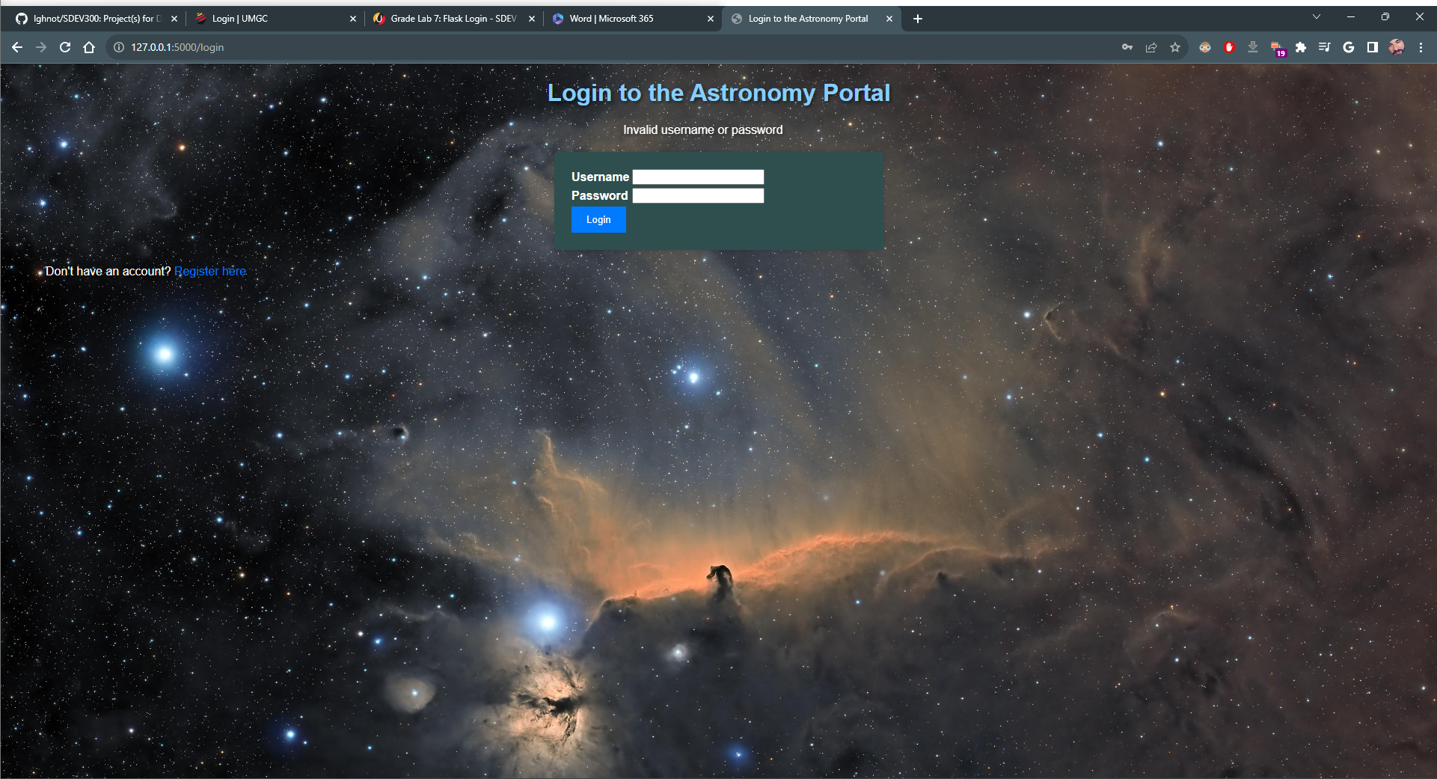

Case 2, registration with existing username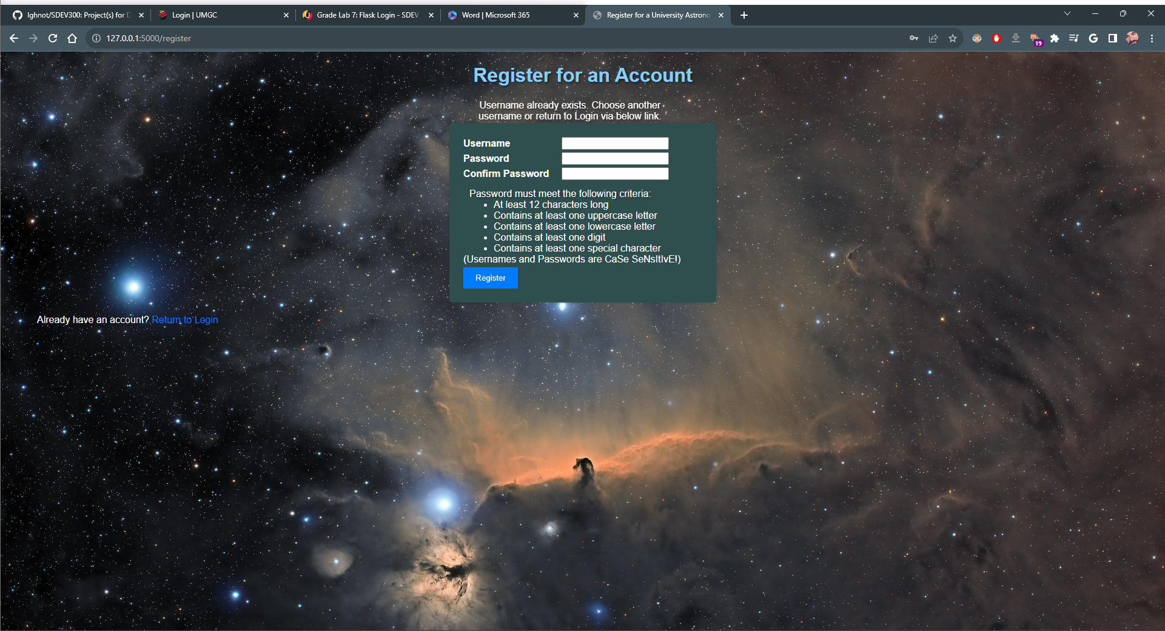

Case 3, passwords don’t match

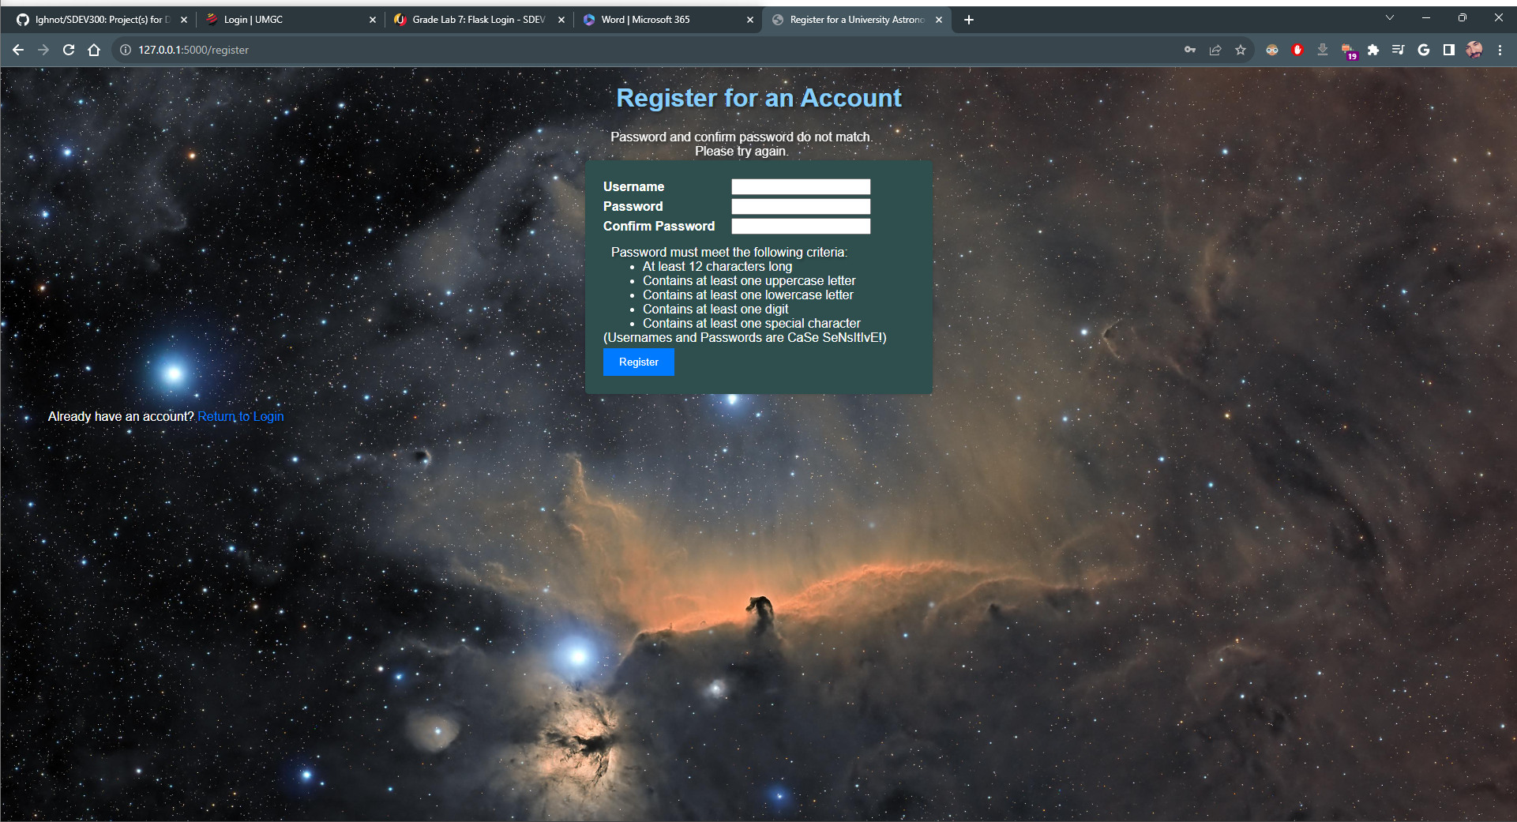

Case 4, Username/Password containing spaces

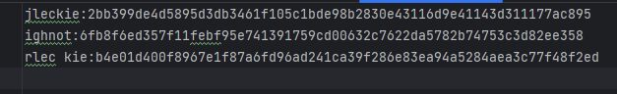

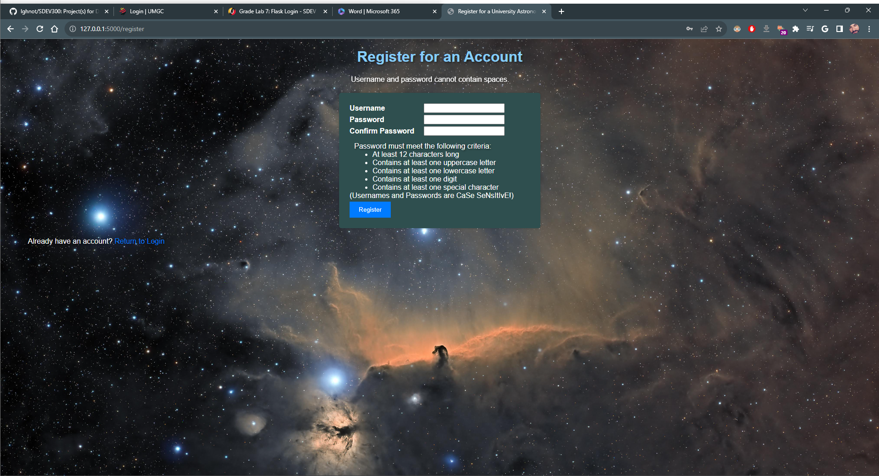

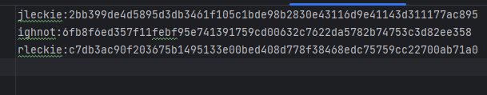

Case 5, Deny unlogged-in access

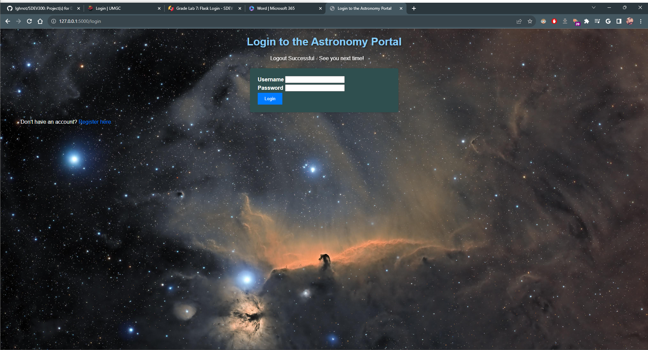

(This shows the successful logout flash message, after which I entered URLs manually as described in the table. The results for all was the login screen, resulting from redirect found in the app.py file for each route.)

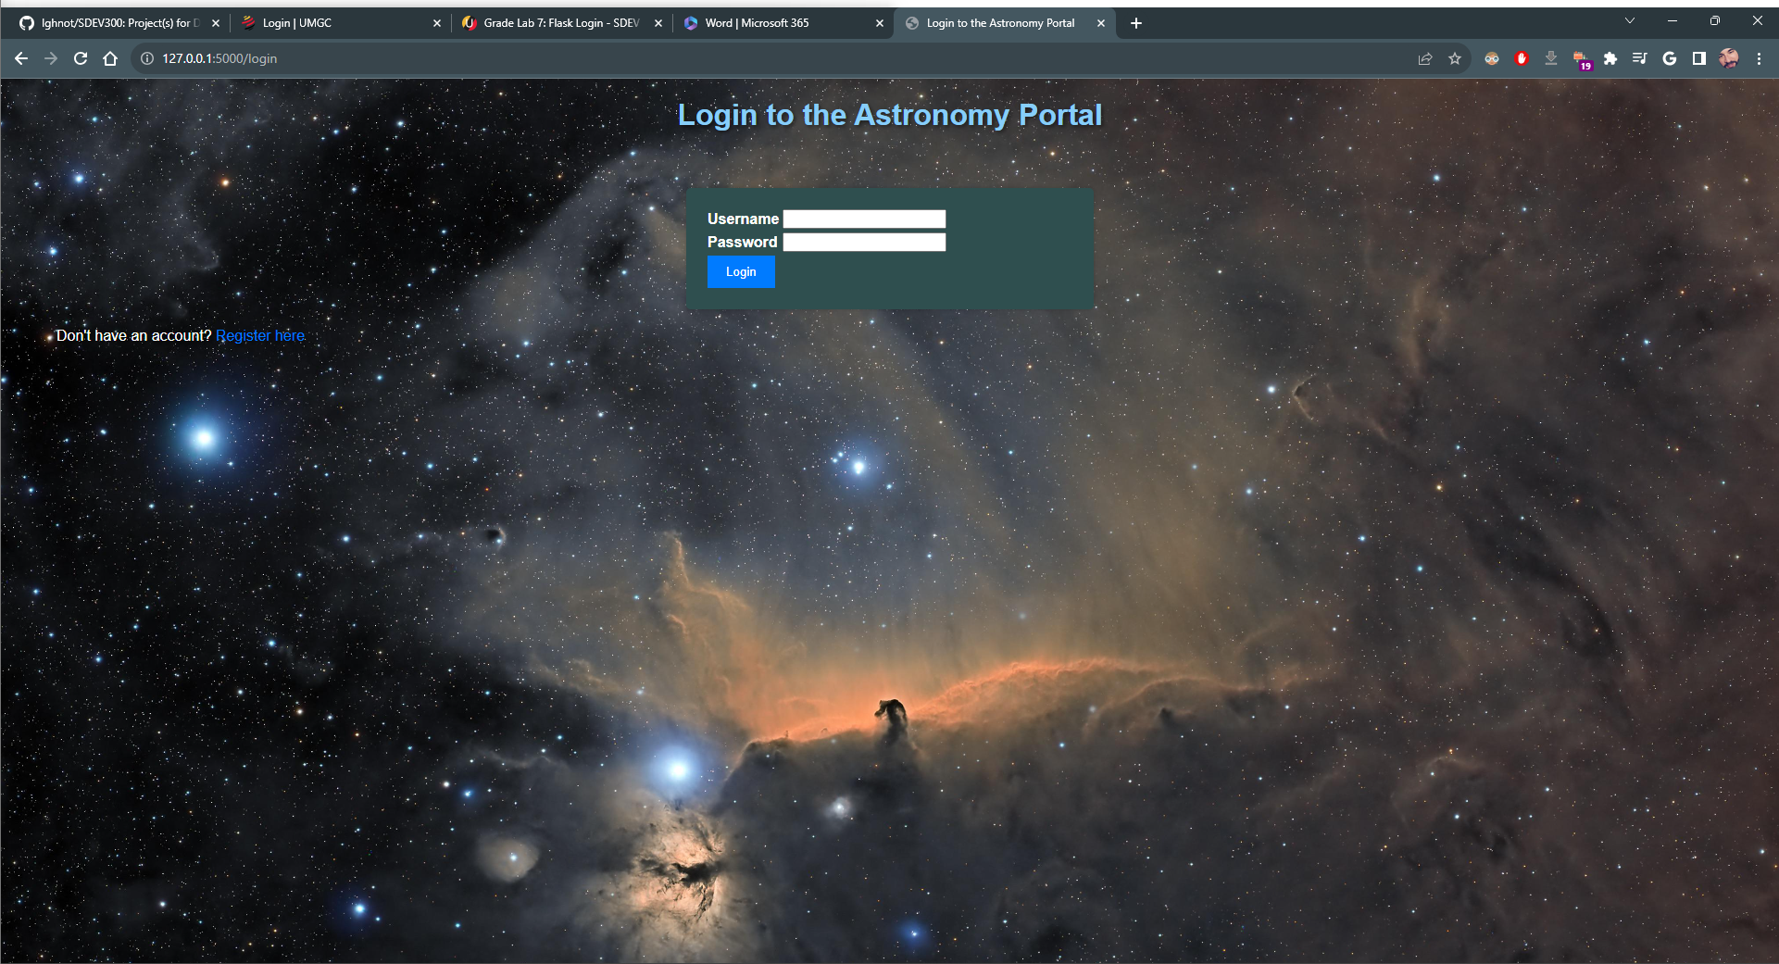

Case 6, Existing login, but incorrect password

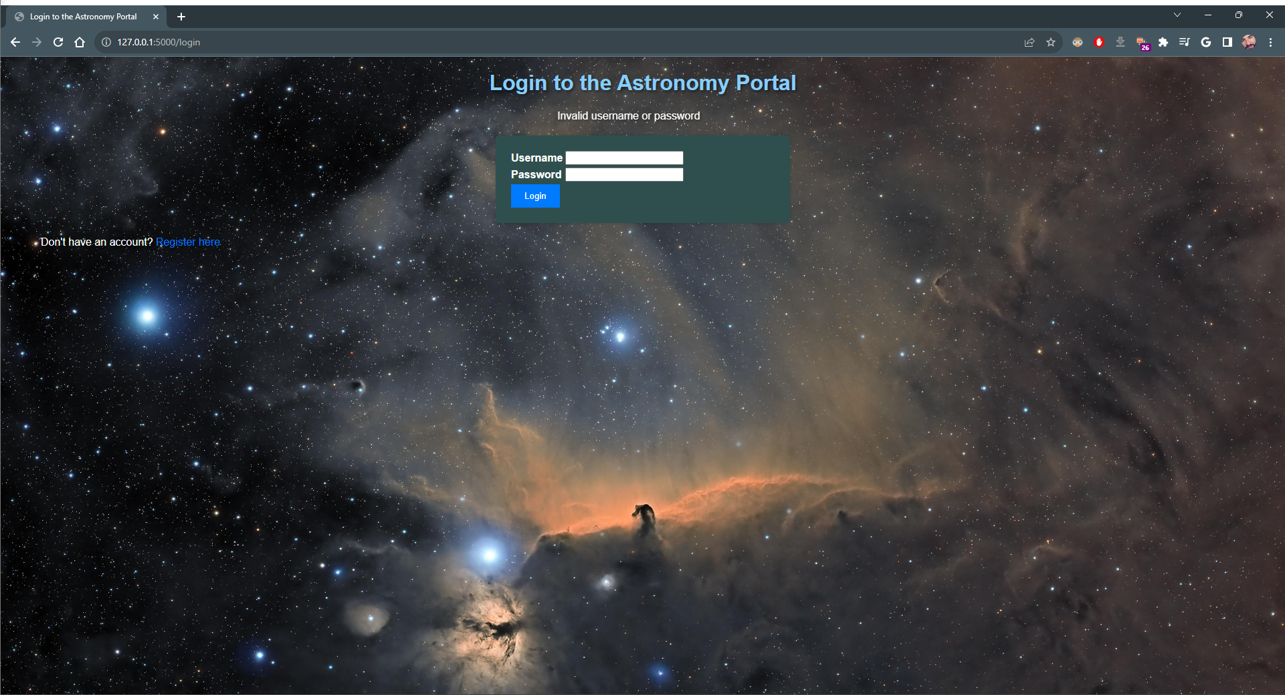

(Table was added to Supercomputer Time page)

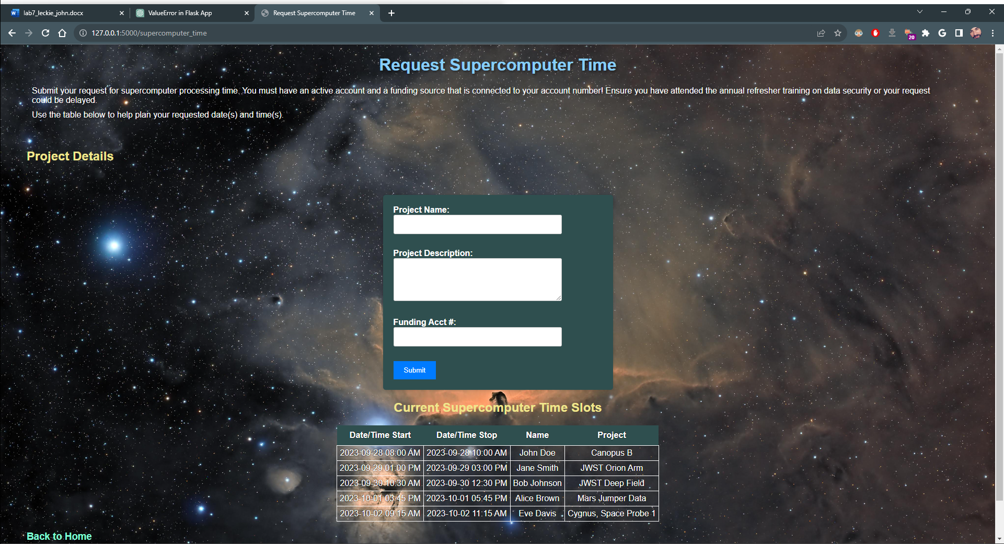

(Additional picture added to Volunteer for Planetarium page)